Test Device for TheLinkBox
by Steven L. Garrett
WB5TTS

To build a simple “TheLinkBox” audio device, find an old CB microphone, a set of amplified speakers, and a USB audio dongle from:
“ http://www.geeks.com/details.asp?invtid=CL-SU4CH&cpc=SCH ”

Part #CL-SU4CH

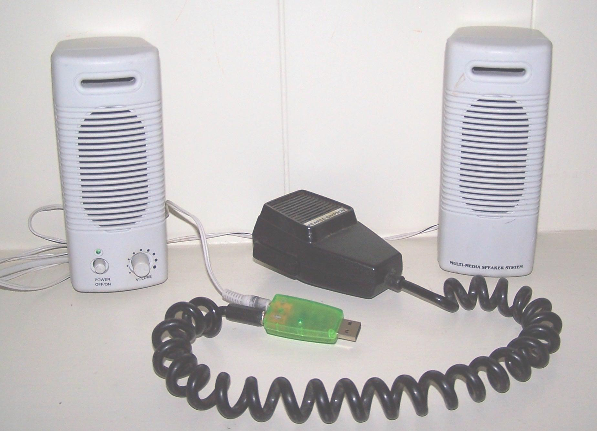

A couple of mods need to be made to the dongle to allow PTT. PTT on the dongle is handled by an input to the Volume Down pin of the CM108 chip. On this dongle it can easily be accessed on the top of the board. Solder a short length of wire (#24 or so) to the surface mount pad.
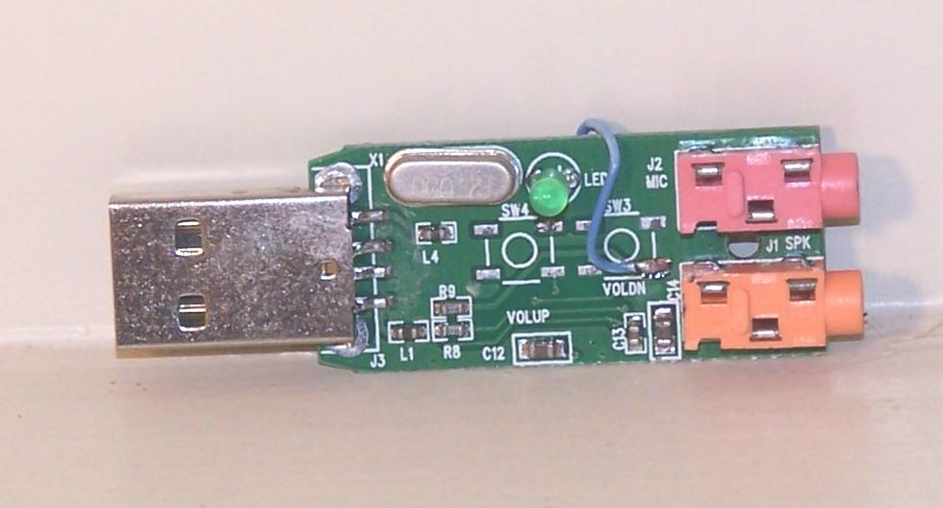
On the back side of the board cut the PC board land going to the middle ring of the microphone connector. Solder the other end of the wire to this point. This ends the modifications to the Dongle.

You may now reassemble the dongle.
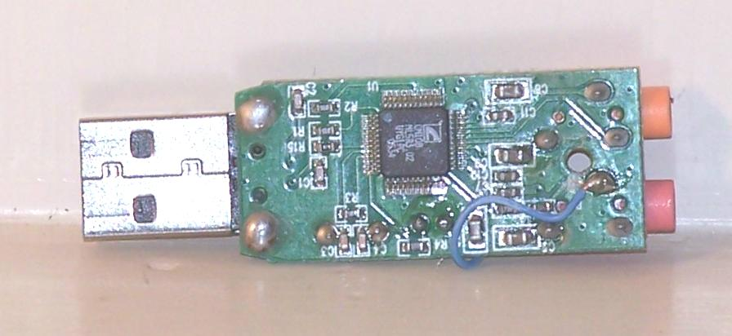
The microphone will need a 1/8” stereo plug attached to it. The ground goes to the shell, microphone to the tip, and PTT to the center sleeve. The other side of the PTT switch goes to ground. The “Volume Down” pin of the CM108 has an internal pull up resistor, so no bias is required.

Plug in the amplified speaker and you should have a functional test device for TheLinkBox.

